

Final Project

Topic: Memories Web Application

Lecturer : So Vengleab

Course: Web Development With Frameword

Year: IV

Semester : I

Academic Year : 2020 – 2021

By Group Member :
Mr. Oum Soknang(Leader)
Mr. Koiy Bottra(Member)
Mr. Chhay Lang

Date : 30 / 03 / 2021
Report

- What is the project about?

- This Web Application is all about the Memories that we have in life. We share our memories by post pic and describe about what we have experience.
- This Web Application is simple that we have only have one page and have functionality Create, Read or View, Update, Delete.

- Why we choose this topic?

- We choose this topic for 2 main reasons:
- Problem:
Difficult to save picture and sometime we have forgotten or confuse delete picture that we have experience.
- Solution:
This system gives us many advantages such as save more time, that we could get view our memories of adventure of user and save space for saving our photo or video and one more thing is cool feature to view.

- What is our goal of making this happen?

Our Goal:
Online Memories web application is advantage for users because they save memories for saving picture or video the their adventure and save time, so don’t have bring with them every time by the way they can check their memories anytime anywhere they only need internet.

- What the difficulty while making this project?

- Our problem when making this project :
- Error : we have met error a lot and some we have solve it and some Cannot solve.
- New Experience : This project is our first time for working with React Native and Node JS and MongoDB, we still inexperience.
- Time : We don’t have enough time for doing this project. We study while working and sometime we have personal problem.
- Sharing : this project we’re research from website, so some source are complete and some are not, so we need to solve the problem that why it make our project delay.
- Handle the problem : again we new experience to this especially MongoDB that we can’t solve the problem up until now that why the project delay and not complete.


- Our future Plan for this project ?
  - We plan on making this project into public we service that have Login and Signup function so the user have their own profile and can save their own memories and update feature to be attractive and more modern.

- Our team Contribution in Project :

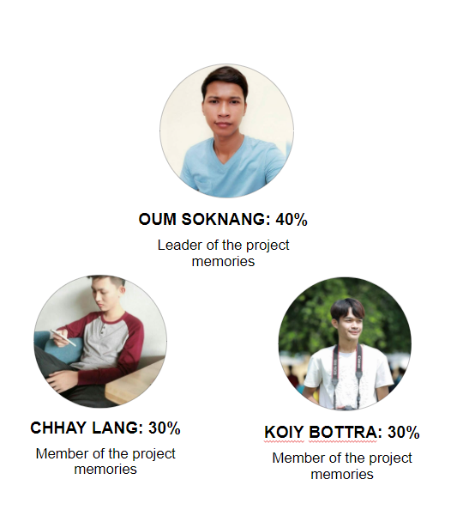

Our Platform

- Frontend
- Home Page : Create and View
- This is the homepage and one the left side is create function, and we can clear when we confuse or writing wrong with button clear.

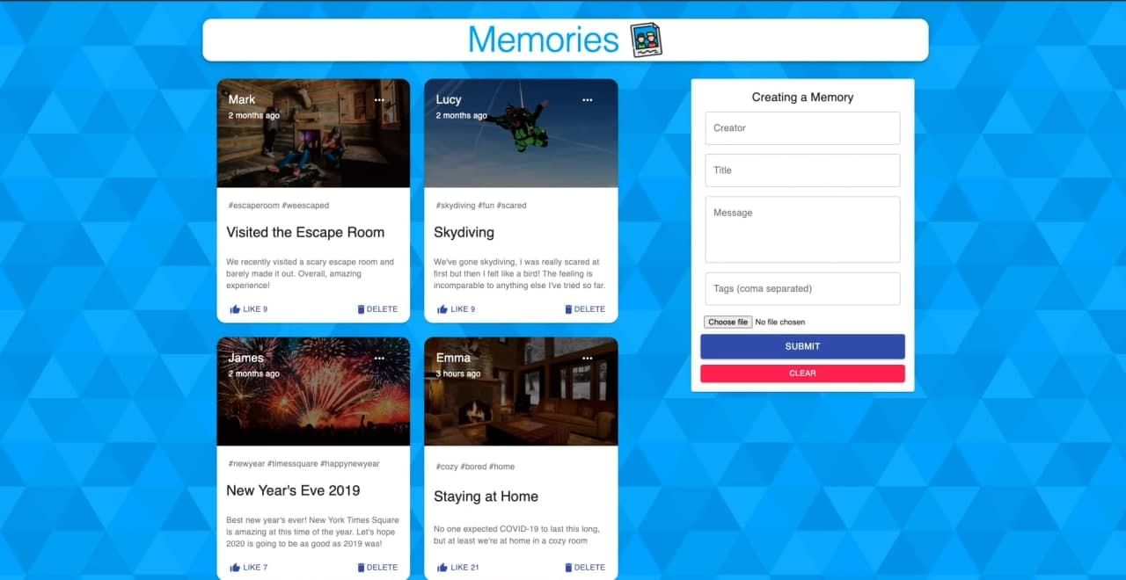
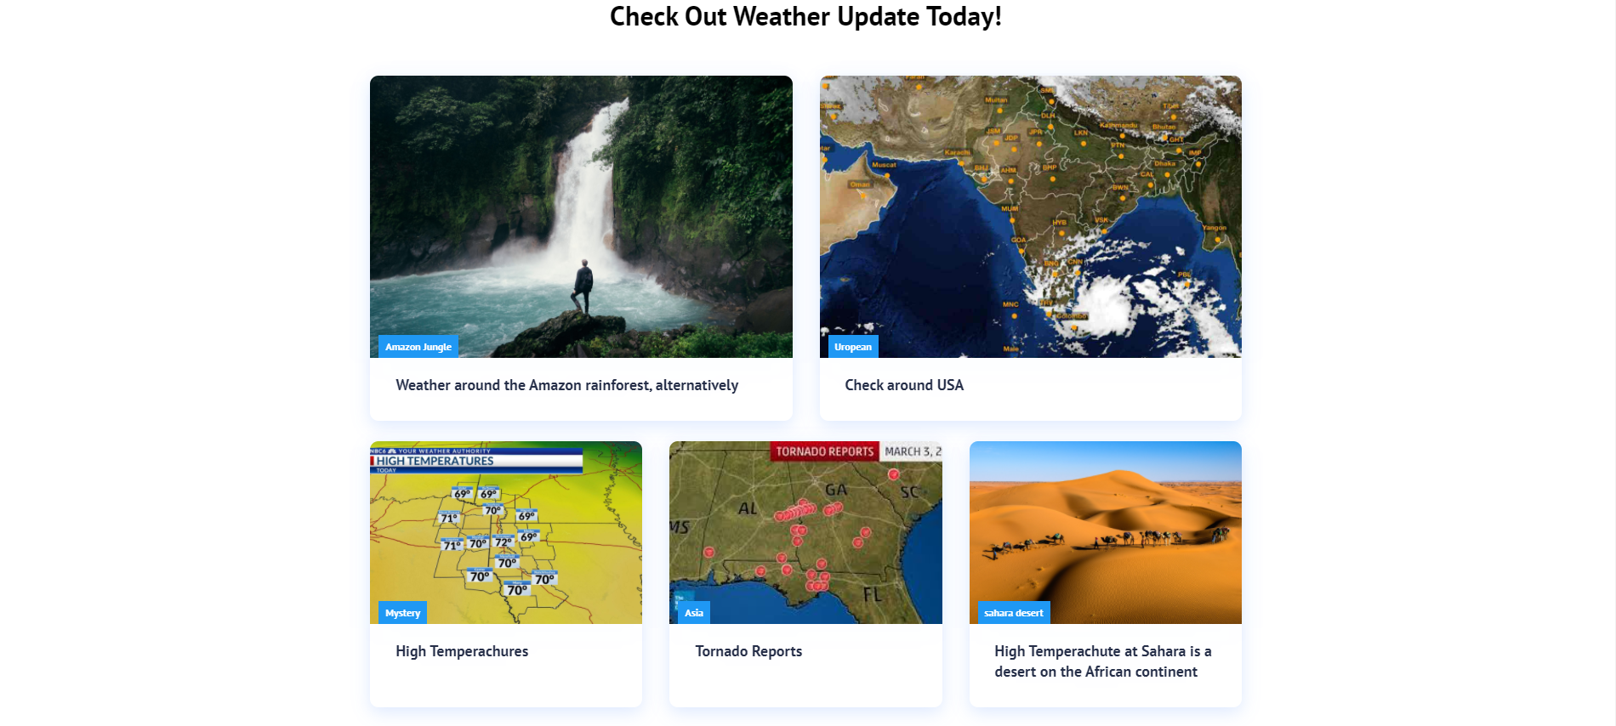

  - Web in Phone :
The size of web will by each device that we use.

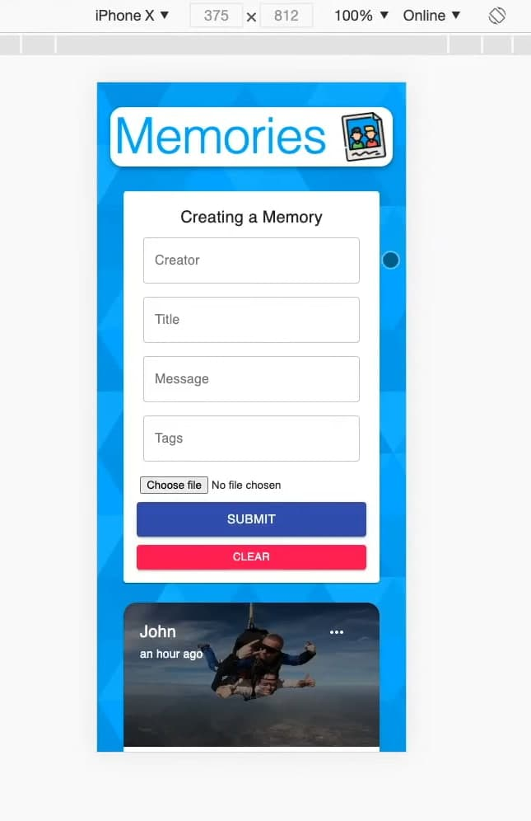
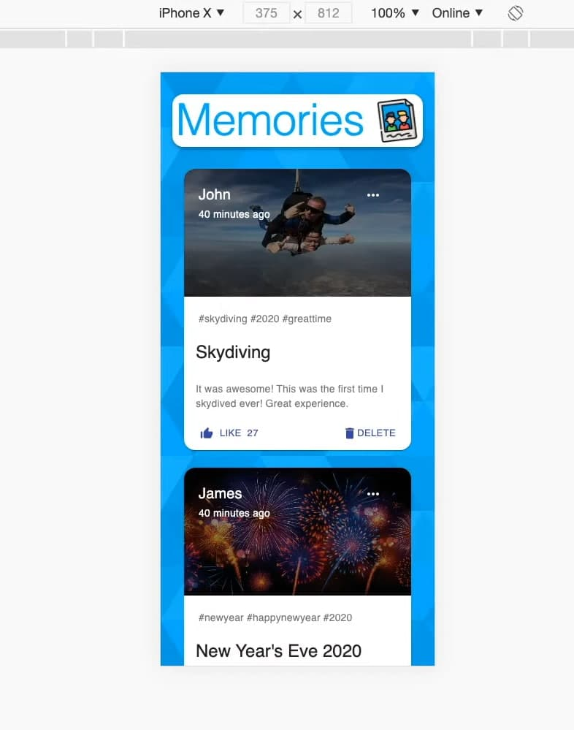

- Home Page : Update and Delete also Like
We update or editing memories by click on the upper left of each view of each memories, we can delete and like the memories too.

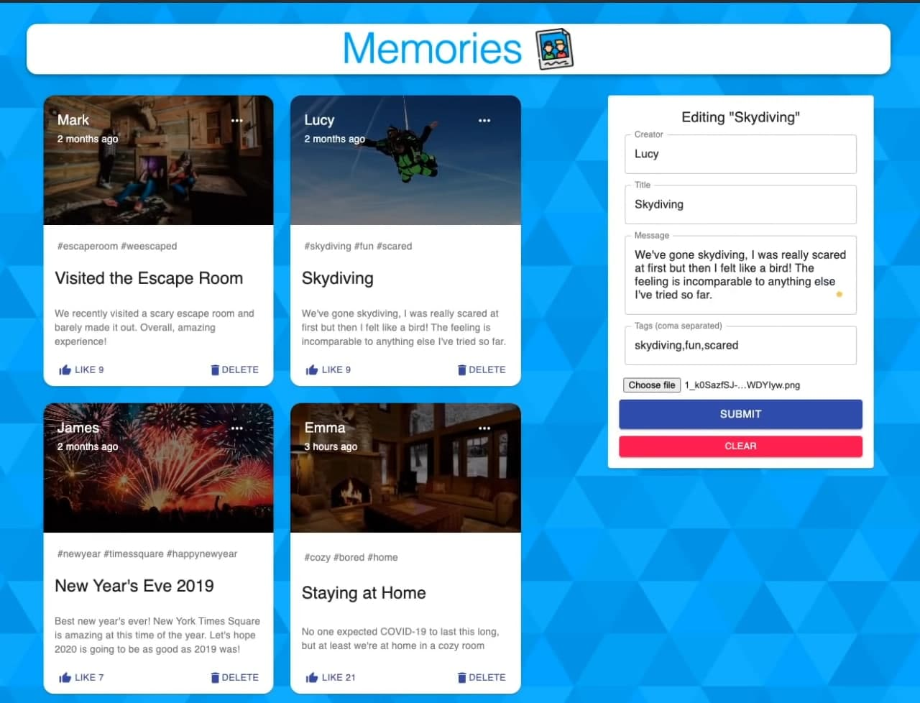

Our Database :
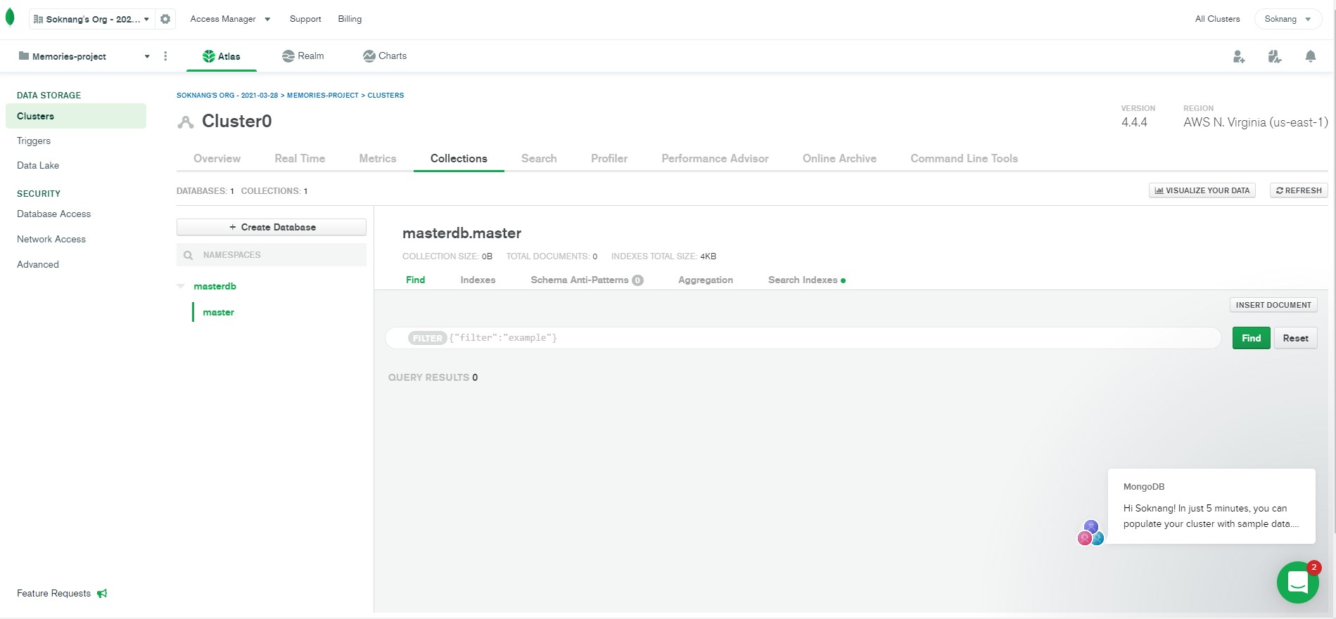

Website references and YouTube link

The most popular database for modern apps | MongoDB
mem.dev: Spaced Repetition Cards
Full Stack MERN Project - Build and Deploy an App | React + Redux, Node, Express, MongoDB [Part 1/2] - YouTube
Create Customizable, Hi-Def, and Scalable Backgrounds (svgbackgrounds.com)
Full Stack MERN Project - Build and Deploy an App | React + Redux, Node, Express, MongoDB [Part 2/2] - YouTube
Sokknang/memories-project (github.com)

 The End 

